Discrete Mathematics
Grade 5

Deb Murphy, Hill City Schools Dmurphy@ISD002.org
Pat Greendahl, Horace May, Bemidji Patrick_Greendahl@bemidji.k12.mn.us
Peter Bahr, Lincoln, Bemidji Peter_Bahr@bemidji.k12.mn.us

Executive Summary:

Unit 1: Interpreting Remainders
*I will be able to explore dividing by two-digit whole numbers.
*I will be able to interpret remainders in a division problem.
*I can write remainders as a fraction or a mixed number.
Minnesota Standards: Number and Operations 5.1.1.1 and 5.1.1.2;

Unit 2: IN/OUT Tables (What’s my rule?)
*I will be able to read a table and recognize and establish a pattern/rule
*I will be able to develop a recursive rule from a given table
*I will be able to develop an explicit rule from a given table
*I will be able to develop a table from a given explicit or recursive rule
Minnesota Standards: Algebra 5.2.1.1

Unit 3: STEM
Problem solving and reasoning skills.
Activity 1 How many different outfits can I make? (1 day)
Activity 2 How seating charts can I make for the class? (1 day)
Activity 3 How many different ways are there to vote for favorites (2 days)
Activity 4 Lets pick a movie for the Party.(1 day)
Activity 5 Mr. Greendahl’s Pizza emporium pizza toppings(1 day)
Activity 6 Problem solving(logic) (2 days)
Activity 7 Choose the fastest route (1day)
Minnesota Standards: Number and Operations 5.1.1.1,

Table of Contents:

- Unit 1: Interpret Remainders (pgs. 5-8)
Lesson 1 ………………………………………………….......……..pg. 5
Lesson 2 ……………………………………………………......…...pg. 5
Lesson 3 ……………………………………………………..………pg. 5
Lesson 4 ……………………………………………………..………pg. 6
Lesson 5 ……………………………………………………..………pg. 6
Lesson 6 ……………………………………………………..………pg. 6
Lesson 7 …………………………………………………………..…pg. 6-7
Lesson 8 …………………………………………………….……….pg. 7-8

- Unit 2: What’s my rule? (IN and OUT tables) .. (pgs. 9-14 )
Lesson 1 ………………………………………………………….pg. 9
Lesson 2 ………………………………………………………….pg. 9-11
Lesson 3…………………...……………………………………..pg. 12-13
Lesson 4 ………………………………………………………….pg. 13
Lesson 5 ………………………………………………………….pg. 13
Lesson 6 ………………………………………………………….pg. 13
Lesson 7 ………………………………………………………….pg. 13-14

- Unit 3: STEM (pgs. 14-20)
Activity 1 ……………………………………………………….pg. 14
Activity 2 ……………………………………………………….pg. 15
Activity 3 ……………………………………………………….pg. 16
Activity 4 ……………………………………………………….pg. 17
Activity 5 ……………………………………………………….pg. 17-18
Activity 6 ……………………………………………………….pg. 18-19
Activity 7 ……………………………………………………….pg. 19-20
Pre/Post Test …………………………………………………pg. 21

Pre-Test
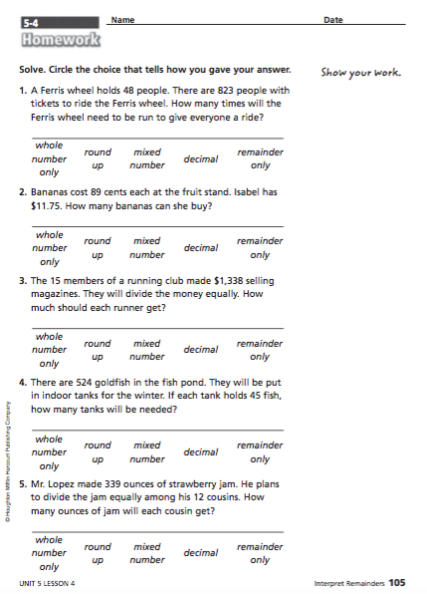

Lesson 1:
Launch -- Read the book “The Remainder of One”. Discuss with students the idea of remainders and what can be done with the remainder. What can be done with the soldier from the story? How
Explore – Have students, with a group, come up with examples of real life situations where there is a remainder and what to do with the remainder.

Lesson 2:
Explore – Have student groups continue discussing their ideas of real life situations with remainders.
Share – Students take turns giving examples that they came up with and what they would do with their remainders and why.
Summarize – Make a class list of different ways they came up with for what to do with the remainder. (round up, ignore, round, make into a fraction/decimal, or use the remainder only).

Lesson3:
Launch –
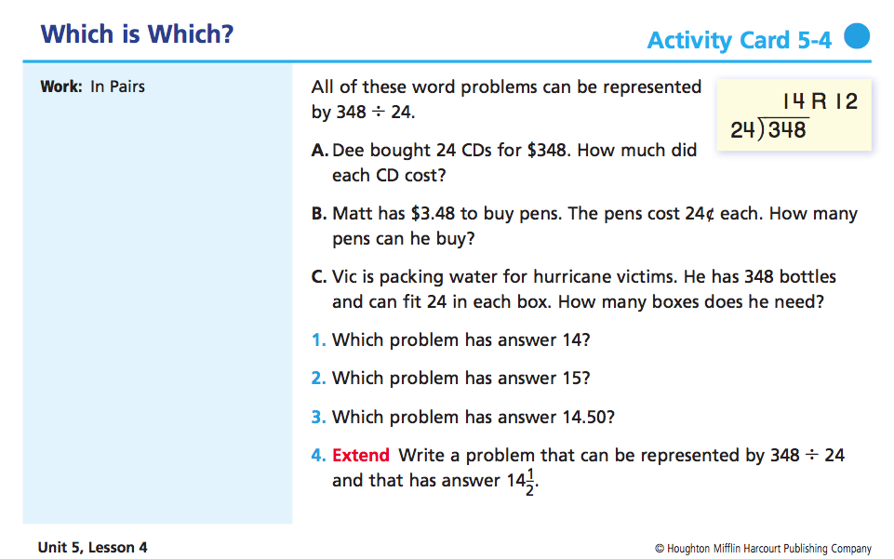
Explore – have students talk about these problems and discuss with the class. Move into talking about dividing with remainders that you round. What kind of situations would you want to round remainders? Give examples on the board and let students work them out together.

Ex: There are 247 people traveling to the basketball game by bus. Each bus holds 52 people. How many buses will be needed?
Share – Have students share their answers. Why do you Round up?

Lesson 4:
Explore – Have students continue working out examples of division problems where you need to round. Talk about situations where you would ignore remainders. Give more examples of word problems where students will need to ignore the remainder. In groups students work together to solve division problems where the remainder is ignored.

Ex: A roll of ribbon is 1,780 inches long. It takes 1 yard of ribbon (36 inches) to wrap a gift. How many gifts can be wrapped?
Share – Have students share their answers. Why do you ignore the remainder?

Lesson 5:
Explore -- Have students continue working out examples of division problems where you need to ignore the remainder. Talk about situations where you would form a decimal with the remainder. Give more examples of word problems where students would form a decimal with the remainder. In groups, students work together to solve division problems where they form a decimal with the remainder.
Ex: A rectangular garden has an area of 882 square meters. The long side of the garden has a length of 35 meters. How long is the short side?
Share – Have students share their answers.

Lesson 6:
Explore -- Have students continue working out examples of division problems where you need to form a decimal with the remainder. Talk about situations where you would form a fraction with the remainder. Give more examples of word problems where students would form a fraction with the remainder. In groups, students work together to solve division problems where they form a fraction with the remainder.

Ex: The 28 students in Mrs. Colby’s class will share 98 slices of pizza equally. How many slices will each student get?
Share – Have students share their answers. How do you get the fraction with your remainder?

Lesson 7:
Explore -- Have students continue working out examples of division problems where you need to form a fraction with the remainder. Talk about situations where you would use only the remainder. Give more examples of word problems where students would only use the remainder. In groups, students work together to solve division problems where they use only the remainder.

Ex: A bagel shop has 138 bagels to be packed into boxes of 12 to be sold. The extra bagels are for the workers. How many bagels will the workers get? Why is the remainder the answer?
Share – Have students share their answers. Why is the remainder the answer?

Lesson 8:
Explore – Have students work in groups to do the activity.
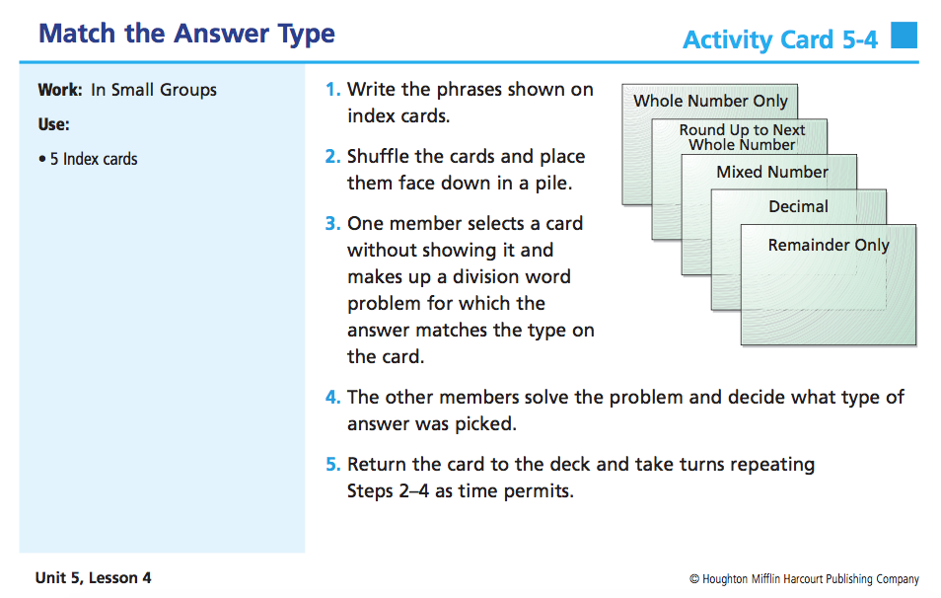

Summarize – Summarize the 5 different ways to interpret the remainder. What is the reasoning for each one?
Assessment – Post-Test

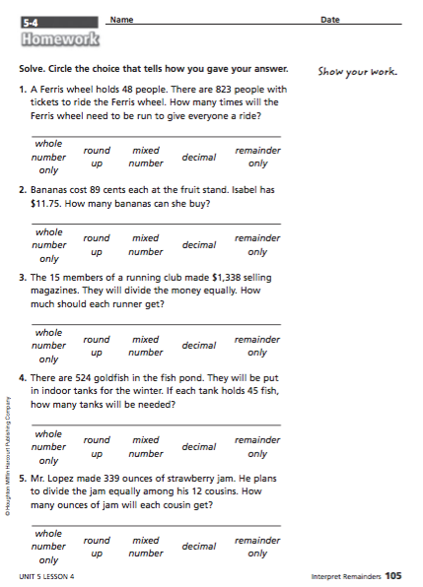

Unit 2: What’s my rule? (IN and OUT tables)
Standards: 5.2.1.1,
Pre-Test (pgs. 11-12)
http://ims.ode.state.oh.us/ODE/IMS/Lessons/Content/CMA_LP_S04_BF_L04_I03_01.pdf

Lesson 1:
Launch—Pick 3 or 4 students that all have something in common to come to the front of the class and tell the class that you are thinking of a rule. See if they can guess your rule. Repeat 3 or 4 times with various students that have some attribute in common. Can we write a rule for each scenario?
Explore – Students make a list of their own rules based on their group members.
Share -- Students share their list of rules with the class.
Explore – Let students come up with rules with various shapes and string creating Venn diagrams. Resource: http://thinkmath.edc.org/resource/guess-my-rule

Summarize – conclusion—Let groups share different rules that they came up with and talk about how patterns can be discovered looking at Venn Diagrams and “What’s my Rule” problems.

Lesson 2:
Launch – Start the day by calling more students to the front for a,” What’s my Rule” problem. Ask, “Can this idea be carried over to use for numbers”? Start with putting up some simple in and out tables for addition and subtraction. Do a couple together first. Write a rule on the board for each scenario. (recursive rule).
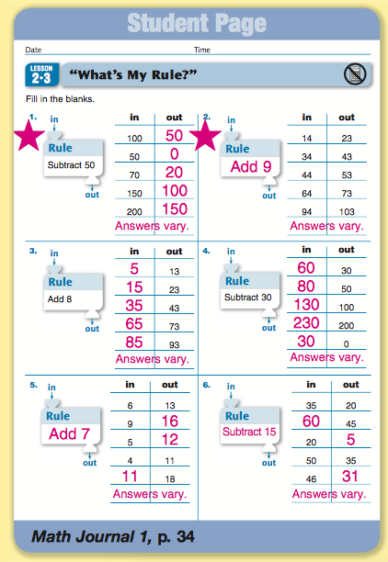
Explore – Working with their group have students identify what the rules are and what the “in’s and out’s” are. Let them explore with blank sheets of “What’s my Rule.”
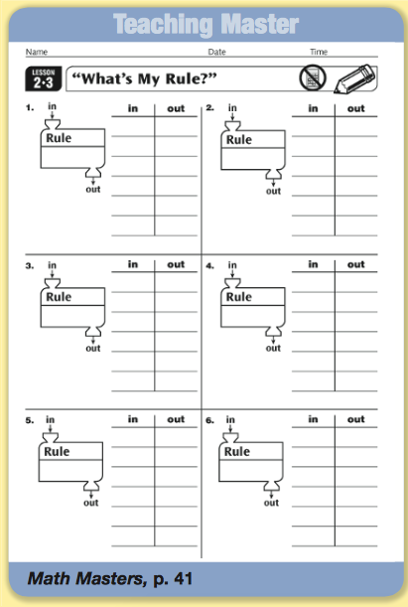
Share – Groups take turns coming to the board and giving their examples. Recursive rules should be written for each.
Lesson 3:
Launch – Revisit the What’s my Rule sheets from the day before. 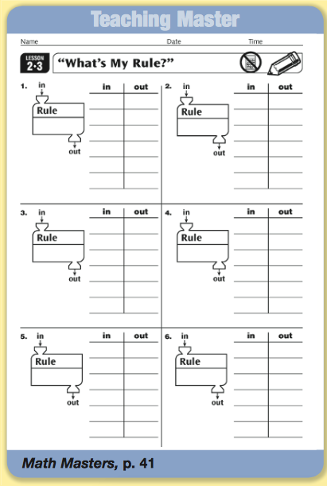
Do these tables work for any function? Multiplying? Dividing?
Explore – Students will explore in and out tables with their groups using multiplying and dividing.
Share – Have students share their findings with the class.
Summarize – Conclude that the tables can be written as a recursive rule.

Lesson 4:
Launch – You may want to use a video or two from Khan Academy, here is a link: https://www.khanacademy.org/math/integral-calculus/sequences-series-approx-calc/calculus-sequences/v/terms-explicit-sequence Tell a story about how tall the trees in your yard are after measuring them and recording them for the past 5 years. Give the students a Recursive rule. Ask, “Can you tell me how tall my trees will be in 10 years?
Explore – Students explore the posed problem and try and come up with a table and an explicit rule.
Share – Students share their rules that they discovered.
Summarize – Can you write an explicit rule based off of the recursive rule?

Lesson 5:
Launch – Tell a story about more trees in your yard. Give the students an explicit rule for the height of the trees.
Explore – Ask students to develop a table and a recursive rule for the height of the trees with their group.
Share – Students share their work and rules with their group and with the class.

Lesson 6:
Launch – Tell the students that you goofed up on your measurements and that your wife went gave you her table of measurements of the trees. Show the students and ask them to come up with a recursive and explicit rule for the table.
Explore – Students work together to come up with the two rules for the table.
Share – Students share and discuss their findings as a whole group and on the board.

Lesson 7:
Launch – Again tell a story, perhaps of a street where the building keep getting taller the further down the street you go. Write out the scenario or repeat if necessary.
Explore – Students need to come up with the three ways to represent the scenario (recursive, table and explicit) within their groups.
Share – Students bring their rules and tables to the board and the class discusses them.
** As an added challenge, you could have students create their own situations and stories for other students to solve, finding the recursive, explicit, and build a table.
Summarize – Tie together the table, recursive, and explicit rules by showing how they relate. Work through one last problem on the board as a class, pointing out each part.
Assess – Post Test (pgs. 15-16)
http://ims.ode.state.oh.us/ODE/IMS/Lessons/Content/CMA_LP_S04_BF_L04_I03_01.pdf

Unit 3: Stem
Activity 1: Combinations --How many different outfits can one wear?

Objective: Students will be able to estimate and compute the number of different combinations of outfits one can make from a given number of shirts, pants, and shoes.

Launch: You know my daughter has been complaining lately that she has absolutely nothing to wear to school anymore. I know I just bought her a bunch of new clothes for school this Fall. We went down to her room and found that she had 2 different pair of new pants that were white, and blue. She also had 3 brand new shirts with the tags still on them. One was green, one was black and the other was orange. She also had two fancy scarves/a hat/socks that grandma gave her for her birthday. She says she has nothing to wear and I beg to differ. Without even considering the hat and socks, how many different outfits can she make from her closet of clothes?

Explore: How many outfits do you think I can make? Students are to use crayons and worksheet that will allow them to color the outfits.

Share: When most of the kids are done I would have them share their answers with myself and the class. I may have one or two groups show their logic on the overhead projector. I would then ask them if there is a mathematical pattern we can follow to figure this out a little faster for these combinations.

2 pants * 3 shirts * 2 scarves = 12 different outfits.

Summarize: Be careful when you say you have nothing to wear. I might ask them to figure out how many combinations they have in their closet and we could probably put something like this on a line plot and find a mean.

Resources:
http://illuminations.nctm.org/Lesson.aspx?id=781

http://ims.ode.state.oh.us/ODE/IMS/Lessons/Content/CMA_LP_S05_BG_L04_I13_01.pdf

http://study.com/academy/lesson/calculating-possible-outcomes-definition-formula-quiz.html

Activity 2: How many different seating charts

Objective: Students will be introduced to permutations and factorials through seating chart orders.

Launch: I will try to explain to my students that the most difficult job as a teacher is to come up with a seating chart. They of course will have objections to that. I will have 2 students come up to the front of the room and discuss and model how many seating charts can be made using 2 people. They will think that was easy so I will proceed to 3 students which should yield 6 different charts.

Explore: Students will work in groups of 2 or 3 and will try to figure out through drawing a picture, making a chart, or whatever means they can to figure out how many different charts could be made if I had a class of 4 students? 5 students? Students should be prepared to share their answers on the board. Through discussion I would record the correct results on the board and ask them if they see any patterns?

Students Seating charts
- 1
- 2
- 6
- 24
- 120

I will introduce to them the vocabulary word factorial and show them what it means.
Examples 2! = 2*1=2 3! =3*2*1= 6 4! = 4*3*2*1= 12

Assess/Extend: Now that you figured out how to do this, since there are 25 kids in class can you tell me how many seating charts I can make? 25! Or 1.41 10^24. I would hope that I would get some sympathy about how tough it would be to create a new seating chart.

Resources:
www.mathmovesu.com/sites/default/files/mmu_dataanalysis_comb_permut.pdf

https://www.khanacademy.org/math/probability/probability-and-combinatorics-topic/permutations/v/permutations-and-combinations-1

Activity 3: How many different ways are there to vote on your favorite?

Objectives: Students will analyze the number of ways a person can vote on their favorite things. Students will also learn to analyze and interpret data using the Borda method, Plurality, and (Plurality with Elimination and head to head) would be and extension to challenge students.

Launch: What is your favorite type of candy/ice cream/pizza restaurant? I would make a list on the board making sure we get a good survey. From this list I would choose two candy choices and have the kids rank from 1 to 2 with 1 being the best and 2 being the worst. I would repeat this next step with a ranking of 1 to 3. I would ask a couple of kids what they chose and from there I would ask them how many different ways/combinations are there for voting results. What if I had added an extra candy so you could rank them 1 to 4? How many ways would there have been to vote?

Explore/Share:
- I would have the students work in small groups to list out all the combinations there could be for a 3 choice candy survey and a 4 candy choice survey.
- I will circulate amongst the groups asking them to show me what they’ve done.
- I will summarize the student answers on the board always looking and asking them if they see a pattern.
- I would list all the correct answers in a chart and look to see if there were any patterns. Responses might be 2*3 =6 6*4 = 24 or 3*2*1=6, or 4*3*2*1 =24
- I would introduce something new called factorial at this time.
- I would access them now by asking them to rank their favorite restaurant/candy on a 1-5 basis and asking them how many combinations there would be and so on up to 10.
Day 2: I would have the kids make up their own survey question. Students would be able to go around and rank their favorites on a scale of 1-3 or 1-4 if they need a challenge. I would have them hold onto the results of their survey for the next activity, which is choosing a winner.

Activity 4: What movie to watch for the Fall Festival. (choosing a winner)

Launch: Students will rank the choices of their movie (candy bars) on a scale of 1 to 3. We will list out on the board of all the different combination of votes we can have. From there we will tally the number of votes for each combination. Once all the data is on the board I would move into the explore section.
Explore. Students will be given time to analyze the data on the board to come up with a winner and why. What choice of movie would be the best backup or which movie would make more people happy?

Share/summarize: During this time we would talk about their choices and I would introduce the word plurality (who got the most number one rankings) would be the choice of movie. I would also show them the Borda Count method which assigns a point value to each ranking. I would give them an example on the board of what the Borda method looks like and have the kids find the winner.

Explore: Students will work in small groups and use the Borda method to find a winner. I would share the results on the board.

Activity 5: Pizza combinations

Objectives: Students will calculate the number of pizza combinations from Mr. Greendahl’s pizza emporium. Students will learn how to make a tree diagram to help solve this problem. How many days eating one pizza combination a day for lunch will it take you to experience all the pizzas in my restaurant?

Launch: There is a new restaurant opening up on school grounds that will allow you options at school. If you ate at my restaurant for lunch every day until you experienced all the 0,1,2,3, topping pizza combinations, How many days would that be or how many different combinations would there be total. You cannot double up combinations.

Explore: After giving the kids the question, I will give them time to attempt the problem using whatever means they can to solve it. Students will work together in small groups and be prepared to share their answer on the board. After discussing all our results I will begin showing the kids using a chart and tree diagrams to help them understand. The results should be the following.

0 toppings = 1 way to order
1 toppings = 8 ways to order
2 toppings = 28 ways to order
3 toppings = 56 ways to order
Total days = 93 days of eating at Mr. Greendahl’s Pizza Emporium

Extend: With this lesson I would introduce the vocabulary Pascal’s Triangle. I could shorten it to 3 topping pizzas or I could have 8 toppings. Which would have be 1+8+28+56+70+56+28+8+1 =256

I may introduce to the kids the take it or leave method. You have two choices (on the pizza or not on the pizza) and 8 toppings. This is 2 to the power of 8= 256.

Information on Pascal’s Triangle and pizza combinations can be found on http://mathforum.org/workshops/usi/pascal/pizza_pascal_answers.html

Activity 6: Heads and Feet

Objective: Students will use problem solving skills such as guess and check, making a chart, drawing a picture, and learn to write an algebraic expression.

Launch: I was out in the barnyard today and I had some trouble counting the number of animals so I bent down and counted 28 legs and 10 heads. My question to you is how many cows and chickens were in the pasture.

More problems:
60 legs and 18 heads======= 12 dogs 6 kids
48 heads and 134 legs=====19 cows 29 chickens
36 legs and 5 heads ants and spiders. =======3 spiders 2 ants
206 legs and 30 heads========13 spiders and 16 ants

Linear equations to introduce:
4d +2K = 28 d+k=18 A+s = 5
d+k = 10 4d +2K =60 6A+8s = 36

Explore: You need to help me out. I need to know how many of each animal there is because the vet is coming out and he needs to bring the right amount of vaccinations for each animal. Please use a chart, guess and check, or whatever method you can to solve.
Share: When students are done with each problem I will have them share their findings to class on the overhead.

Summarize:
With each problem I do I will write down and example of a linear equation (algebra) for them to help introduce it to them. I may even show the students that need to be challenged how to solve it.

Resources:
http://home.avvanta.com/~math/guess.html

Day 2 “Save the World” ( Beatles Bridge crossing dilemma)

Launch: Mike, Bill, Keith and Sara are in quite a dilemma. They need to cross this rickety old bridge with holes in it at night. They only have one flashlight which they need to cross and can only cross at the rate of the slowest person. Mike can cross in 1 minute, Bill can cross in 5 minutes, Keith is slow and it takes him 10 minutes and last but not least it takes Sara 2 minutes to cross. I can ask them two of the following question.
- What is the fastest time they can cross that bridge?
- If they needed to cross in 17 minutes to save the world, could it be done?
Explore: Students will work in groups of 4 and 5 and I will give them a flashlight to use. They are to use act it out, and logic to solve the problem. They should record their answers on paper and should be prepared to share with the class their results.

Share: I will pick two groups to share their findings. One will be the group with 19 minutes and the other will be the group with 17.

Summarize: Students will realize in order to solve the problem the two slowest had to go over together to kill two birds with one stone.

M&S-------2 min
1 min------M
K&S-------10 min
S----------2 min
M&S------2 min
Total 17 min.

Resource:
http://puzzles.nigelcoldwell.co.uk/twentyfive.htm

Activity :7 Choose the fastest route

Launch: Will is planning on delivering May baskets to all of his girlfriends’ houses. His mother is making his favorite supper tonight and he does not want to be late so he wants to deliver the May baskets as quickly as he can. Use the chart below and find the shortest possible route for him to take. Will needs to start at his house and end at his house.

Will Sue Lucy Allie
Will 0 9 13 9
Sue 9 0 10 8
Lucy 13 10 0 7
Allie 9 8 7 0
Answer: 8+7+10+9= 34

Will Sue Lucy Allie Greta

Will 0 9 13 9 20
Sue 9 0 10 8 3
Lucy 13 10 0 7 8
Allie 9 8 7 0 5
Greta 20 3 8 5 0

Explore: Students can work in small groups to try to figure out a strategy to solve this problem. After a while I will show them how to create weighted graph to help complete the circuit. I will then have them complete a weighted graph for the next problem and try to find the quickest route available. (36 is the shortest) This is called the nearest neighbor.

Share: Have students put their graphs on the board and compare their paths. Class discussion. Pose the question: Could there be a faster route?

Pretest/Posttest

1.

Mike needs to deliver his birthday invitations to his friends. He needs to get it done as fast as he can. Look at the mileage chart and choose the shortest route to make his deliveries. He needs to start and stop at his own house.

Mike Bill Fred John
Mike 0 5 3 9
Bill 9 0 11 6
Fred 3 11 0 4
John 9 6 4 0

2. How many different outfits can I wear if I have 3 different colored(red, blue, green) shirts, 4 different colored pants(brown, orange, tan, yellow), and two different hats(Vikings, Twins).

3. I look into my yard and see 60 legs and 18 heads. I know there are kids and dogs in the yard. How many of each is there out there?

4. At my pizza shop I have 4 different toppings available, pepperoni, sausage, olives, and chicken. How many different 2 topping pizzas can I make?

5. Sara, Timmy, Mike, and Nick are standing in a line. How many different ways can I put them in order?

